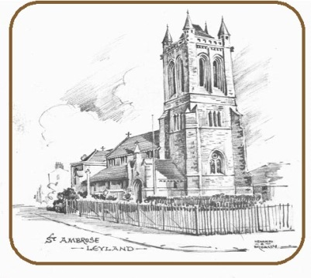
St. Ambrose Church, Moss Lane, Leyland

Child Protection and Safeguarding Policy
Hirer’s Agreement

St. Ambrose Church is committed to the safeguarding and protection of all children and young people and of any adult who may, for any reason, be considered to be vulnerable. We recognise and take our responsibility to safeguard and promote the welfare of children and young people within the legal framework of the 1989 Children’s Act.
A full copy of our policy can be found on the website and is available from the church office upon request.
We ask that anyone hiring a hall or room within Halls for All makes themselves aware of our policy. They should agree to abide by the guidelines, particularly with reference to:
- Being responsible for the health and safety of children whilst on our premises, ensuring appropriate qualified adult supervision and care at all times.
- Ensuring that all children are collected by known and responsible adults.
- Ensuring that no child/children are left alone with one adult in an enclosed area.
- Being alert to ‘strangers’ who may try to access the building during the hiring period.

Name: _____________________________________________________________________
Hire period: _________________________ Date: _________________________________

Signed: ____________________________________________________________________

